**ROUTING PROTOCOLS**

Nikhil Agarwal1, Prachi Gandhi2, Nehal Varshney3

**Abstract**—Routing is one of the most fundamental areas of networking, which determines how your data (like videos, messages, voice notes, etc) gets to its destination and completes the process of transfer from the source of that data. In a computer network, the transmission of data is based on the routing protocol which selects the best routes between any two nodes. There are various types of different routing protocols which perform well under different circumstances to give the best results according to the situation in which it has been used. Through this paper, we aim to display the working of a few of the well-known routing protocols that are Static Routing protocol and Dynamic Routing protocols which include ( RIP protocol, OSPF protocol – these are intradomain routing protocols and BGP – which is an interdomain routing protocol). We will be showing the working of these protocols through a simulation which will include nodes and edges for explaining the working of these protocols along with that we will also be maintaining tables which will help in identifying the connections as well as the distance between the connected nodes.

**Index Terms**— Simulation, protocols, static, dynamic, interdomain, intradomain, connections, networking, nodes, distance, routing, destination, source.

—————————— ◆ ——————————

# 1 Introduction

A protocol is a set of rules that reveals how computer systems communicate with each other across a network. It is a combination of rules and procedures that lets routers on the Internet inform each other about any changes that have taken place. A routing protocol also acts as the common medium through which different applications, hosts, or systems can communicate. The data messages are exchanged when different computers communicate with each other. Examples of messages are sending or receiving e-mail, videos, voice notes, etc. establishing a connection to a remote machine, and transferring files and data. Routing protocols are of two types static and dynamic routing protocols. In static routing protocols all the routes between nodes are entered manually and if any changes take place between the routes of two nodes, the information is updated manually, while in dynamic routing protocols the information is updated automatically. Routing protocols can further be classified as Intradomai routing protocol and Interdomain routing protocols. Routing inside an autonomous system is referred to as intradomain routing, whereas Routing between autonomous systems is referred to as interdomain routing. The Routing protocols that we will be demonstrating in our project are Routing Information Protocol (RIP), Open Shortest Path First (OSPF) and Border Gateway Protocol (BGP)

1. **Static Routing Protocol:**

**Static routing** is a form of [routing](https://en.wikipedia.org/wiki/Routing) that is used when a router uses a manually-configured routing entry, rather than information that gets updated dynamically(automatically). Unlike [dynamic routing](https://en.wikipedia.org/wiki/Dynamic_routing), static routes remain fixed and do not show any changes if the network is changed or if it is reconfigured. Static routing and [dynamic routing](https://en.wikipedia.org/wiki/Dynamic_routing) can be found not to mutually exclusive. Both dynamic routing and static routing can be used on a router to maximize routing efficiency

and to provide backups in the cases that dynamic routing information fails to be automatically updated. Static routing is generally used to define an exit point (default route) from a router in situations when no other routes can be found available. Static routing can be used for small networks that require only one or two links.

**2. Routing Information Protocol:**

 Routing Information Protocol (RIP) is an implementation of the distance vector protocol. Routing Information Protocol (RIP) is one of the oldest dynamic routing protocols which uses hop count as a routing metric to find the best path between the source and the destination network. Updates (routing information) is broadcasted, sending the entire updated table, the information is updated periodically.

**3.Open Shortest Path First:**

Open Shortest Path First is a routing protocol for Internet Protocol networks. It works on the link state routing algorithm and falls into the group of interior gateway protocols, operating inside a single autonomous system. It works on the principle of [Dijkstra's algorithm](https://en.wikipedia.org/wiki/Dijkstra%27s_algorithm), also known as the shortest path first (SPF) algorithm.OSPF uses the flooding technique that is, it checks all  
possible routes between source and destination and picks the shortest route(best route).

The goal of this study is to show the implementation of these above mentioned protocols with the help of graphs that contain nodes(representing as routers for the understaning of the user) and edges which will demonstrate the distance between these routers.The main objective of our project is to demonstrate the working of these routing protocols so that the user can visualize them for a better understanding.

**2 Literature Review**

* D Sidhu et al [1] have worked upon the stimulation model of OSPF protocol.
* SL Murphy, MR Badger [2] have shown the working of OSPF protocol through the use of cryptography
* D Xu, [L Trajkovic](https://scholar.google.com/citations?user=JbDLLakAAAAJ&hl=en&oi=sra) [3] evaluated the performance of the dynamic protocols using OPNET
* V Vetriselvan et al [4] evaluated the dynamic protocols along with certain criteria’s like Jitter, Convergence Time, end to end delay, etc
* Fitigau, Toderean [5], evaluated RIP, OSPF and EIGRP routing protocols in OPNET simulator and using various simulation scenarios to compare their performance
* Ud Din, Mahfooz [6], analysed routing protocols RIP, OSPF, IGRP and EIGRP with the parameters such as packets dropping, traffic received, end to end delay and jitter in voice
* P Rakheja et al [7] have evaluated the dynamic protocols on a number of factors like cost of delivery, amount of overhead on each router, number of updates needed, failure recovery, delay encountered and resultant throughput of the system
* Shah. A, J. Rana [8] give a comparative analysis of routing protocol EIGRP, OSPF and RIP for real time applications.
* Thorenoor [9] tells us how to make mplementation decisions when the choice is amongst   
  protocolsthat involve distance vector or link state or the combination of both.
* Krishnan, Shobha [10] have compared between the BGP and OSPF routing protocols.
* [Jayaprakash](https://scholar.google.com/citations?user=4sJ05_UAAAAJ&hl=en&oi=sra), Saroja [11] have shown the implementation of dynamic routing protocols using cisco packet tracer.
* Deng el al [12] have displayed the working of dynamic routing protocols with the help of OPNET

# 3 Data Resources

For the implementation of our stimulation, we will be using our own data set which will be generated by the user randomly. To make the stimulative project we have used Html, canvas, JavaScript and sublime as our text editor.

**4 Methodology**

1. Static Routing Protocol: For the implementation of static protocol we have used canvas as the base for making our model in which we have taken 5 nodes (representing the routers) and the edges between them representing the distance between the routers.Below the nodes we have shown 5 tables (each table for each node), as of now we are generating the graph by ourselves, i.e when the graph button has been clicked by the user, a graph will be generated by itself and also the tables will be filled automatically , making the job convinient for the user (our future prospect aims at taking the information from the user as well). In the table we can see that the value 0 has been used for depicting self loop and the value 1000 has been used to show that there is no connection between those two nodes.The user can now decide between which two nodes they wish to see the shortest path, as soon as the user will enter the two nodes it wishes to check and then clickes on the submit option, the user will see a visual of the shortest path being chosen between the two nodes they selected and the distance between them.
2. Routing Information Protocol: To visualize the working of this protocol the user can click on the graph option which will generate a graph, now the user can also add additional edges along with their weights between the nodes if they wish to.Five tables have been used to depict the connections of each node in the graph. In the table we can see that the value 0 has been used for depicting self loop and the value 1000 has been used to show that there is no connection between those two nodes. If the user enteres a new edge along with the weight, the table will get updated accordingly by acquiring the information from the table of it’s neighbouring node. For the working of this protocol Bellman Ford algorithm has been used. Using this algorithm, we will find the shortest path between the source node and destination node (as chosen by the user) in the following way-This algoritm finds the shortest path from every node to every other node. in the first step we initialize the distance from the source to all vertices as infinite and distance to the source itself as 0. Then we relax the node V-1 times (where V is the number of vertices), in relaxation we perform the following step:

Do the following for each edge u-v

* If dist[v] > dist[u] + weight of edge uv, then update

therefore, dist[v] = dist[u] + weight of edge uv.

By following this algorithm, the RIP returns the shortest path to the user.

3.Open Shortest Path First:

To visualize the working of this protocol the user can click on the graph option which will generate a graph, now the user can also add additional edges along with their weights between the nodes if they wish to.Five tables have been used to depict the connections of each node in the graph. In the table we can see that the value 0 has been used for depicting self loop and the value 1000 has been used to show that there is no connection between those two nodes. If the user enteres a new edge along with the weight, the table will get updated accordingly, there is a separate update optio for each invidual node’s table to get updated or if the user wishes to update all the tables together, they ca use the update all option. The algorithm used here to find the shortest path between the nodes is Djikstra algorithm which works as follows-

We create a empty array (suppose min[])

The algorithm assigns a distance value to all vertices in the input graph it initializes all distance values as infinite and assigns distance value as 0 for the source vertex so that it is picked first.

While min[] doesn’t include all vertices:

* Pick a vertex u which is not there in min[] and has minimum distance value.
* Update distance value of all the adjacent vertices of the vertex u.
* To update the distance values, iterate

through all the adjacent vertices.

* For every adjacent vertex v, if sum of distance value of u (from source) and weight of edge u-v, is less than the distance value of v, then update the distance value of v.

**5.Results:**

With the help of our model we can calculate the shortest distance between the source node and the destiation node by using any of the 3 protocols, i.e:

* Static Routing
* Routing information Protocol
* Open Shortest Path First Protocol

In the result the user can see the shortest route obtained which will be marked with the help of red lines for a clear visual, simultaneously the user will also get an updated table for each node that represents the next hop and the distance between the nodes.

**6.Performace Analysis:**

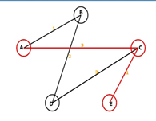

We are able to get the desirable shortest path be-

tween the source node ad destinatio node accu

rately.

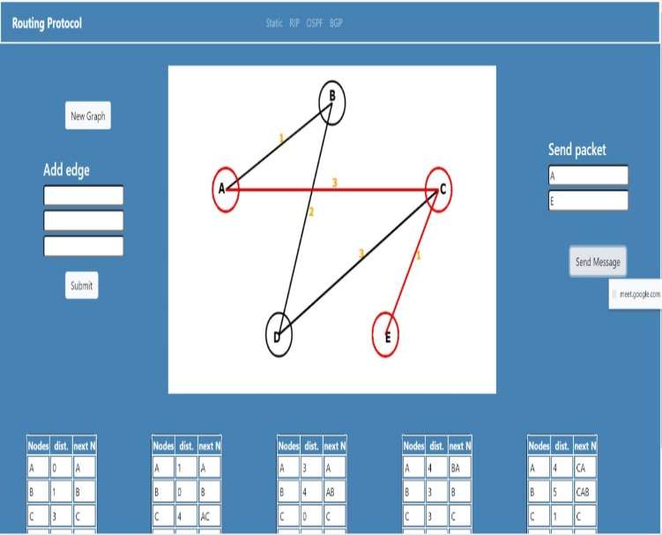

The table gets accurately updated when new in

formation is entered or any path is changed.

# 7. Conclusion

The main purpose as we can see from the re-

sults is to give a brief idea of the working of the

static as well as the dynamic routing protocols

that are used for delivering the message(data)

form sender to the receiver. Through this project

we have tried to show how the various algorithms

work to select the shortest(best) path possible to

transmit the data, which is choosen automatically

in the case of dynamic routing protocols and

manually (usually by the user) in case of static

routing protocol.

**8. Acknowledgment**

The authors wish to thank Dr. Kuldeep and Dr.

Vijay Kumar Bohat for motivating and helping us

to take upthis project and work on it.

# References

1. D Sidhu, T Fu, S Abdallah, R Nair… - ACM SIGCOMM Computer …, 1993 - dl.acm.org
2. SL Murphy, MR Badger - Proceedings of Internet Society …, 1996 - ieeexplore.ieee.org
3. D Xu, [L Trajkovic](https://scholar.google.com/citations?user=JbDLLakAAAAJ&hl=en&oi=sra) - 2011 - summit.sfu.ca
4. V Vetriselvan, [PR Patil](https://scholar.google.com/citations?user=EAXc_K4AAAAJ&hl=en&oi=sra), M Mahendran - International Journal of Computer …, 2014 - Citeseer
5. Loan fitigau and Gavril Toderean, "Network Performance Evaluation for RIP, OSPF and EIGRP Routing Protocols", IEEE 2013
6. IKram Ud Din, Saeed Mahfooz and Muhammad Adnan, “Analysis of the routing protocols in the Real Time Transmission: A Comparative study”, Global Journal of Computer Science and Technology, Vol. 10, Issue 5, Ver. 1.0, July 2010, pages 18-22.
7. [P Rakheja](https://scholar.google.com/citations?user=IfWxnY8AAAAJ&hl=en&oi=sra), [P Kaur](https://scholar.google.com/citations?user=8rbOGyYAAAAJ&hl=en&oi=sra), A Gupta, [A Sharma](https://scholar.google.com/citations?user=L3qpRP4AAAAJ&hl=en&oi=sra) - International Journal of Computer …, 2012 – Citeseer
8. Shah. A and Waqas J. Rana, "Performance Analysis of RIP and OSPF in Network Using OPNET", IJCSI International Journal of Computer Science Issues, Vol. 10, Issue 6, No.2, Novermber 2013
9. SG Thorenoor - 2010 Second International Conference on …, 2010 - ieeexplore.ieee.org
10. [YN Krishnan](https://scholar.google.com/citations?user=S5GRv4UAAAAJ&hl=en&oi=sra), [G Shobha](https://scholar.google.com/citations?user=yy58AFYAAAAJ&hl=en&oi=sra) - 2013 International Conference on …, 2013 - ieeexplore.ieee.org
11. [MR Jayaprakash](https://scholar.google.com/citations?user=4sJ05_UAAAAJ&hl=en&oi=sra), MK Saroja - International Journal of Research in …, 2015 - academia.edu
12. J Deng, S Wu, K Sun - ENSC 427: Communication Networks. Final project …, 2014 - sfu.ca
13. <https://www.geeksforgeeks.org/classes-of-routing-protocols/>
14. <https://en.wikipedia.org/wiki/Routing_protocol>